D**ATA SCIENCE & MACHINE LEARNING**

**LAB CYCLE 2**

**1. Create a three dimensional array specifying float data type and print it.**

**Program**

import numpy as np

array = np.arange(1,30,1.1).reshape(3,3,3)

print(array)

print(array.dtype)

**Output**

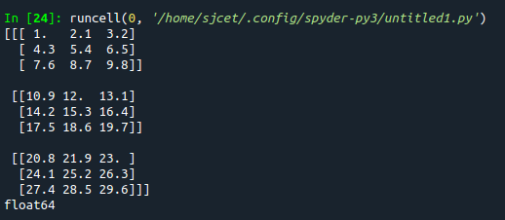

**2. Create a 2 dimensional array (2X3) with elements belonging to complex data type and print it. Also display**

**a. the no: of rows and columns**

**b. dimension of an array**

**c. reshape the same array to 3X2**

**Program**

import numpy as np

array = np.arange(6).astype(complex).reshape(2,3)

print(array)

print("rows and columns\n", array.shape)

print("dimention\n", array.ndim)

arr2 = array.reshape(3,2)

print("reshape\n", arr2)

**Output**

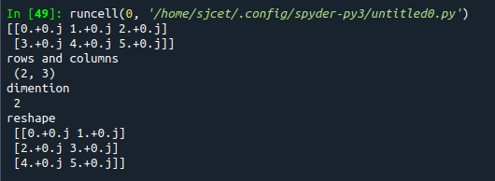

**3. Familiarize with the functions to create**

**a) an uninitialized array**

**b) array with all elements as 1,**

**c) all elements as 0**

**Program**

import numpy as np

a = []

print(a)

#1

print(np.empty(2))

#2

print(np.ones(5))

#3

a=(3,2)

print(np.zeros(a))

**Output**

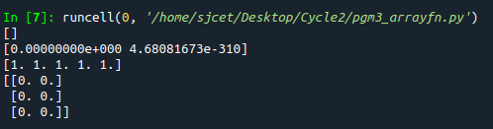

**4. Create an one dimensional array using arange function containing 10 elements.**

**Display**

**a. First 4 elements**

**b. Last 6 elements**

**c. Elements from index 2 to 7**

**Program**

import numpy as np

print(np.arange(1, 11, 1))

# 1

print(np.arange(1, 5, 1))

# 2

print(np.arange(5, 11, 1))

# 3

print(np.arange(3, 8, 1))

**Output**

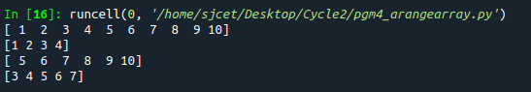

**5. Create an 1D array with arange containing first 15 even numbers as elements**

**a. Elements from index 2 to 8 with step 2(also demonstrate the same**

**using slice function)**

**b. Last 3 elements of the array using negative index**

**c. Alternate elements of the array**

**d. Display the last 3 alternate elements**

**Program**

import numpy as np

array=np.arange(0,15,2)

print(array)

print("Elements from index 2 to 8\n",array[2:8])

print("Last 3 elements of the array using negative index\n",array[-3:])

print("Alternate elements of the array",array[::2])

**Output**

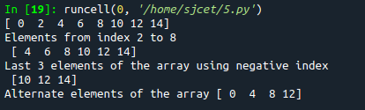

**6. Create a 2 Dimensional array with 4 rows and 4 columns.**

**a. Display all elements excluding the first row**

**b. Display all elements excluding the last column**

**c. Display the elements of 1 st and 2 nd column in 2 nd and 3 rd row**

**d. Display the elements of 2 nd and 3 rd column**

**e. Display 2 nd and 3 rd element of 1 st row**

**f. Display the elements from indices 4 to 10 in descending order(use**

**–values)**

**Program**

import numpy as np

x = np.array([[2, 4, 6,1], [6, 8, 10,1],[1, 2, 1,1], [1, 1, 1,1]])

print(x)

#1

print("excluding first row\n",x[1:])

#2

print("excluding last column\n",x[:,:3])

#3

print("Display the elements of 1st and 2nd column in 2nd and 3rd row")

print(x[1:3,0:2])

#4

print("dispaly 2 and 3 element",x[:1,1:3])

#5

print("display 2nd and 3rd element of 1st row")

print(x[0:1,1:3])

#6

arr=np.array([1,6,8,10,1,1,2])

sarr=np.sort(arr)[::-1]

print(sarr)

**Output**

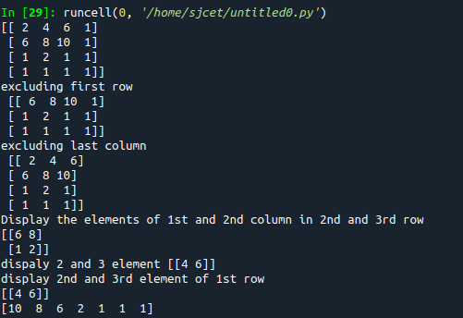

**7. Create two 2D arrays using array object and**

**a. Add the 2 matrices and print it**

**b. Subtract 2 matrices**

**c. Multiply the individual elements of matrix**

**d. Divide the elements of the matrices**

**e. Perform matrix multiplication**

**f. Display transpose of the matrix**

**g. Sum of diagonal elements of a matrix**

**Program**

import numpy as np

array = np.arange(1,5,1).reshape(2,2)

array2 = np.arange(6,10,1).reshape(2,2)

print ("\n", array)

print ("\n", array2)

print ("\nsum of two 2darrays is: \n", array + array2)

print ("\n2darrays subtracted: \n", array - array2)

print ("\nproduct of individual elements: \n", array * array2)

print ("\n2darrays divided: \n", array / array2)

matrixprod = np.matmul(array, array2)

print("\nproduct of two matrices\n", matrixprod)

transpose = np.transpose(array)

print("\ntranspose of 1st array\n", transpose)

transpose2 = np.transpose(array2)

print("\ntranspose of 2nd array\n", transpose2)

sumofd = np.trace(array)

print("\nsum of diagonal elements of 1st array\n", sumofd)

sumofd2 = np.trace(array2)

print("\nsum of diagonal elements of 2nd array\n", sumofd2)

**Output**

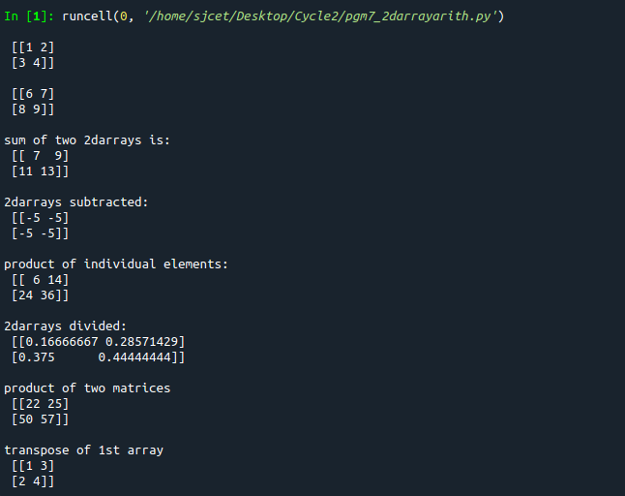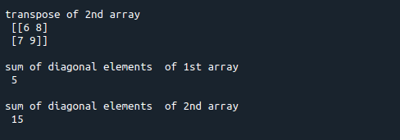

**8. Demonstrate the use of insert() function in 1D and 2D array**

**Program**

import numpy as np

arr1 = np.arange(10, 16)

print("1D ARRAY ")

print("\nThe array is: ", arr1)

obj = 2

value = 40

arr = np.insert(arr1, obj, value, axis=None)

print("\nAfter inserting the new array is: ")

print(arr)

print("\nShape of the new array is : ", np.shape(arr))

print("\n2D ARRAY ")

arr1 = np.array([(1, 2, 3), (4, 5, 6), (7, 8, 9), (50, 51, 52)])

print("\nThe array is: ")

print(arr1)

print("\nThe shape of the array is: ", np.shape(arr1))

a = np.insert(arr1, 1, [[50], [100]], axis=0)

print("\nNew array is : ")

print(a)

print("\nShape of the array is: ", np.shape(a))

**Output**

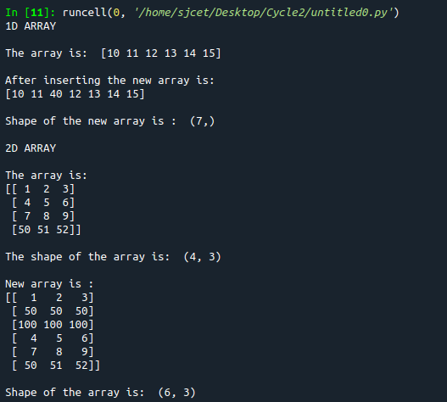

**9. Demonstrate the use of diag() function in 1D and 2D array.**

**Program**

**Program**

import numpy as np

a= np.array([[3, 6,7,8]])

b=np.array([[3, 6,8,7], [4, 2,1,0],[3,1,3,3],[1,1,2,2]])

print("\n",a)

print("\n",b)

x=np.diag(a)

y=np.diag(b)

print("diagonal of 1d\n",x)

print("diagonal of 2d\n",y)

**Output**

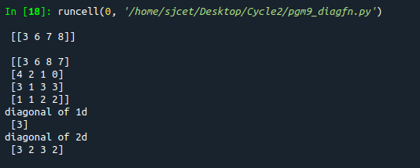

**10. Demonstarte the use of append() function in 1D and 2D**

**array.**

**Program**

import numpy as np

a = np.array([(1, 2, 3), (4, 5, 6)])

b = np.array([1, 2, 3])

print("First array:")

print(a)

print("Second array")

print(b)

print("\n")

print("Append elements to array:")

print("\n2darray")

print(np.append(a, [7, 8, 9]).reshape(3, 3))

print("\n1darray:")

print(np.append(b, [7, 8, 9]))

**Output**

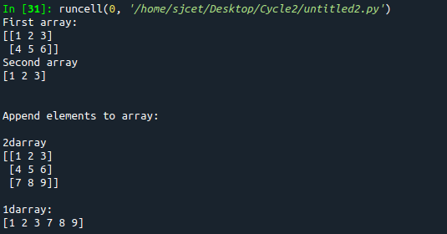

**11. Demonstarte the use of sum() function in 1D and 2D array.**

**Program**

import numpy as np

a=np.array([0.4,0.5])

b=np.sum(a)

print ("\nsum:", b)

**Output**



**12.Create a 1 Dimensional array .Display the elements from indices 4 to 10 in descending order(use–values)**

**Program**

import numpy as np

a = np.array([1,2,8,9,3,4,5,6,7,10])

print(a)

array_copy = np.sort(a)[::-1]

print("sorted array desc",array_copy)

print("sliced 4:10:",array_copy[4:10])

**Output**

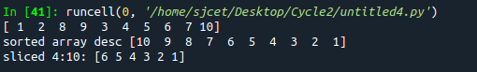

**1. Create a square matrix with random integer values(use randint()) and use**

**appropriate functions to find:**

**i) inverse**

**ii) rank of matrix**

**iii) Determinant**

**iv) transform matrix into 1D array**

**v) eigen values and vectors**

**Program**

import numpy as np

arr1 = np.arange(10, 16)

print("1D ARRAY ")

print("\nThe array is: ", arr1)

obj = 2

value = 40

arr = np.insert(arr1, obj, value, axis=None)

print("\nAfter inserting the new array is: ")

print(arr)

print("\nShape of the new array is : ", np.shape(arr))

print("\n2D ARRAY ")

arr1 = np.array([(1, 2, 3), (4, 5, 6), (7, 8, 9), (50, 51, 52)])

print("\nThe array is: ")

print(arr1)

print("\nThe shape of the array is: ", np.shape(arr1))

a = np.insert(arr1, 1, [[50], [100]], axis=0)

print("\nNew array is : ")

print(a)

print("\nShape of the array is: ", np.shape(a))

**Output**

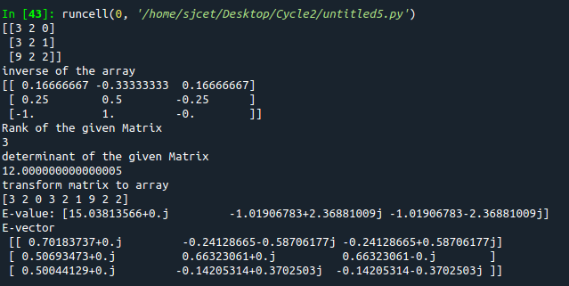

**2. Create a matrix X with suitable rows and columns**

**i) Display the cube of each element of the matrix using different methods**

**(use multiply(), *, power(),**)**

**ii) Display identity matrix of the given square matrix.**

**iii) Display each element of the matrix to different powers.**

**iv) Create a matrix Y with same dimension as X and perform the operation X 2 +2Y**

**Program**

import numpy as np

arr1=np.arange(4,8).reshape(2,2)

print("\narray\n",arr1)

#1

print("\ncube using power\n")

b=np.power(arr1,3)

print(b)

f=arr1**3

print("\n",f)

print("\ncube using multiply\n")

c=np.multiply(arr1,arr1)

d=np.multiply(c,arr1)

print("\n",d)

e=arr1*arr1*arr1

print("\n",e)

#2

print("\nidentity matrix\n")

h=np.identity(2)

print("\n",h)

#3

print("\nDisplay each element of the matrix to different powers.")

i=np.power(arr1[0][0],2)

j=np.power(arr1[0][1],3)

k=np.power(arr1[1][0],4)

m=np.power(arr1[1][1],5)

print("\n",i)

print("\n",j)

print("\n",k)

print("\n",m)

#4

print("\nCreate a matrix Y with same dimension as X and perform the operation X 2 +2Y")

arr2=np.arange(0,4).reshape((2,2))

print("\n",arr2)

n=np.power(arr1,2)

o=np.multiply(2,arr2)

print("\n",o)

p=np.add(n,o)

print("\n",p)

**Output**

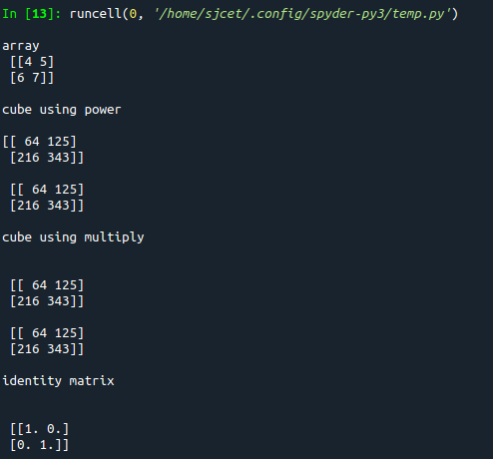

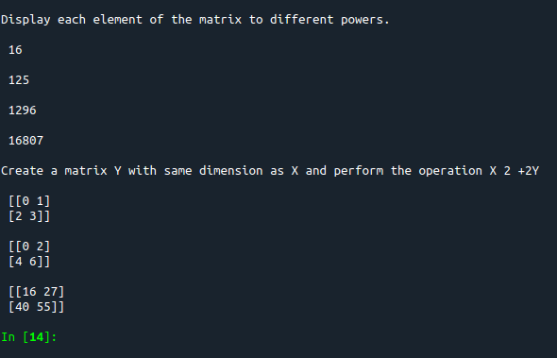

**3. Multiply a matrix with a submatrix of another matrix and replace the same in larger**

**matrix.**

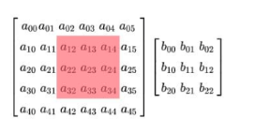

**Program**

import numpy as np

print("\nLarge matrix")

arr1=np.arange(1,37).reshape((6,6))

print(arr1)

print("\nsmall matrix")

arr2=np.arange(1,10).reshape((3,3))

print(arr2)

print("\ncutout portion")

a=arr1[0:3,1:4]

print(a)

print("\nmultiplying with smaller matrix")

c=np.multiply(a,arr2)

print(c)

print("\nfinal matrix")

arr1[0:3,1:4]=c

print(arr1)

**Output**

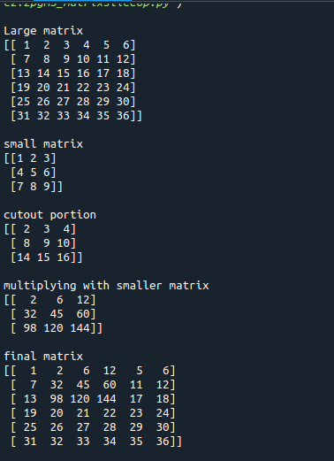

**4. Given 3 Matrices A, B and C. Write a program to perform matrix multiplication of**

**the 3 matrices.**

**Program**

import numpy as np

#matrix multiplication of 3 matrices.

arr1=np.arange(1,10).reshape((3,3))

arr2=np.arange(11,20).reshape((3,3))

arr3=np.arange(21,30).reshape((3,3))

print("\n1stmatrix")

print(arr1)

print("\n2ndmatrix")

print(arr2)

print("\n3rdmatrix")

print(arr3)

a=np.multiply(arr1,arr2)

b=np.multiply(a,arr3)

print("\nThe product of 3 matrices:")

print(b)

**Output**

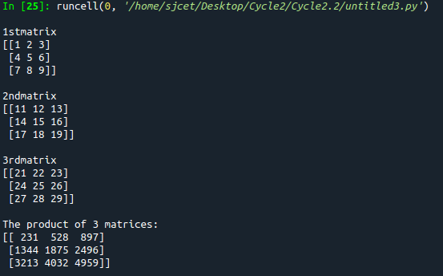

**5. Write a program to check whether given matrix is symmetric or Skew Symmetric.**

**Program**

import numpy as np

a= np.array([[1, 2, 3],

[2, 1, 2],

[3, 2, 1]])

x=np.transpose(a)

print(a)

c=np.array_equal(a, x)

print("symmetric or not:" ,c)

b=np.negative(a)

print(b)

d=np.array_equal(x,b)

print("skew symmetric or not:",d)

**Output**

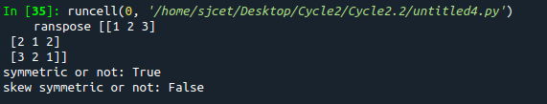

**6. Write a program to find out the value of X using solve(), given A and b as above**

**Solving systems of equations with numpy**

**One of the more common problems in linear algebra is solving a matrix-vector equation.**

**Here is an example. We seek the vector x that solves the equation**

**A X = b**

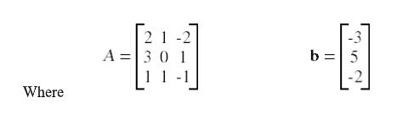

**And X=A -1 b.**

**Numpy provides a function called solve for solving such eauations.**

**Program**

import numpy as np

a=np.array([[2,1,-2],[3,0,1],[1,1,-1]])

b=np.array([[-3],[5],[-2]])

print(a)

print(b)

x = np.linalg.solve(a, b)

print(x)

**Output**

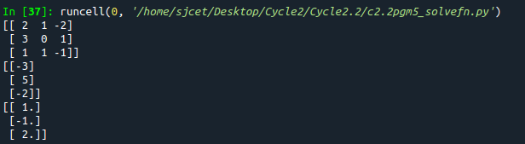

**7. Write a program to perform the SVD of a given matrix. Also reconstruct the given matrix**

**from the 3 matrices obtained after performing SVD.**

**Singular value Decomposition**

**Matrix decomposition, also known as matrix factorization, involves describing a given**

**matrix using its constituent elements.**

**The Singular-Value Decomposition, or SVD for short, is a matrix decomposition method for**

**reducing a matrix to its constituent parts in order to make certain subsequent matrix**

**calculations simpler. This approach is commonly used in reducing the no: of attributes in**

**the given data set.**

**M= U ∑V^T**

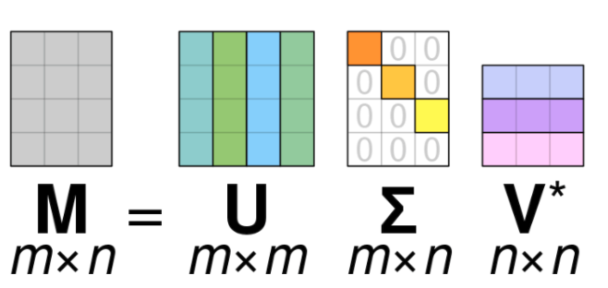

**• M-is original matrix we want to decompose**

**• U-is left singular matrix (columns are left singular vectors). U columns contain**

**eigenvectors of matrix MMᵗ**

**• Σ-is a diagonal matrix containing singular (eigen) values.**

**• V-is right singular matrix (columns are right singular vectors). V columns contain**

**eigenvectors of matrix MᵗM**

**Numpy provides a function for performing svd, which decomposes the given matrix into 3**

**matrices.**

**Program**

from numpy import array

from scipy.linalg import svd

from numpy import dot

from numpy import diag

A = array([[1, 2,1], [3, 4,2], [5, 6,4]])

print(A)

U, s, VT = svd(A)

print(U)

print(s)

print(VT)

Sigma=diag(s)

B=U.dot(Sigma.dot(VT))

print(B)

**Output**

